**(Mapping in Solidity | Solidity Latest Version):**

In Solidity, mapping is a data structure used to store key-value pairs, somewhat similar to dictionaries or hash maps in other programming languages.

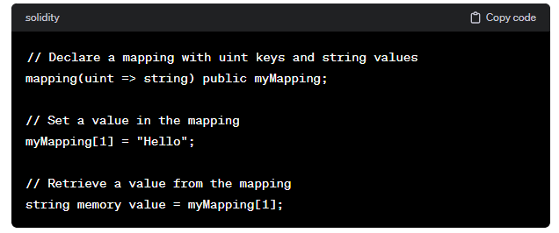

Mappings can be used with various data types as keys and values, including other mappings or custom data structures. It's important to note that mappings in Solidity are not iterable, meaning you cannot directly loop through all the keys or values in a mapping. If you need to iterate over the keys or values, you might need to maintain an additional data structure like an array or use a different approach depending on your specific use case.

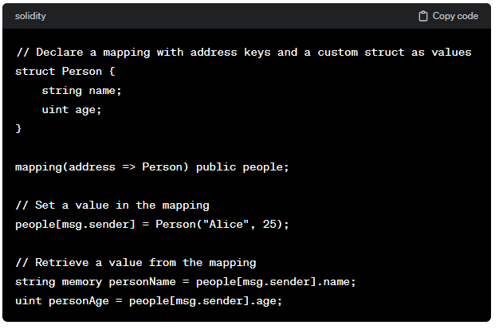

* Concept of keys and values.
* Mapping (key=> value).

**Code:**

//SPDX-License-Identifier: GPL-3.0

pragma solidity 0.8.0;

contract demo{

    mapping(uint=>string) public roll_no;

    function setter(uint keys,string memory value) public

    {

        roll_no[keys]=value;

    }

}

**Output:**

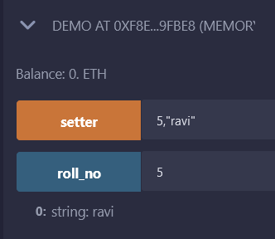

//SPDX-License-Identifier: GPL-3.0

pragma solidity 0.8.0;

contract Mapping{

    mapping(uint=>string) public emp_id;

    function setIds() public {

        emp_id[31]="gaurav";

        emp_id[27]="aman";

        emp_id[33]="sadqwd";

        emp_id[20]="amdrewe";

        emp_id[14]="dqsasas";

    }

    function getId(uint _id) public view returns(string memory){

        return emp_id[_id];

    }

}

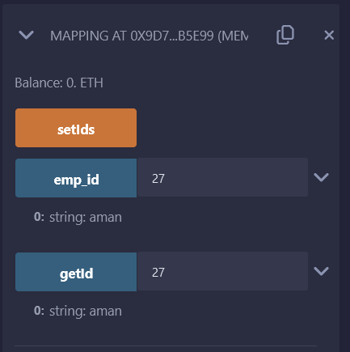

**Now the code for advance mapping**

Here we are trying to add older donation + new donation so finally we get the updated amount.

//SPDX-License-Identifier: GPL-3.0

pragma solidity 0.8.0;

struct donor_dts{

    string name;

    uint age;

    string add;

    uint don;

}

contract advMapping{

    mapping(address=>donor_dts) public acc_info;

    function set(string memory _name, uint _age, string memory _add, uint _don) public{

        acc_info[msg.sender] = donor_dts(_name,_age,_add,acc_info[msg.sender].don+_don);

    }

    function delete_Info() public{

        delete acc_info[msg.sender];

    }

}

**Output:**

